
Supplier’s Guide

Policies & Procedures



Supplier Information
ID Form

March/2022

klöckner pentaplast

Dear Supplier,
Please find the Necessary Documentation and Signatures required to ensure efficient Supplier Creation.
We request these details in order to avoid fraudulent activity and to ensure that we pay to the correct bank details.
It is essential that we receive data from one of the Options below which are relevant for your geographical region.
All details in regard to our Legal Entities, invoicing process, communication and supplier requirements can be found on the following link www.kpfilms.com/supplier-Info.

Necessary documentation required for Supplier creation:
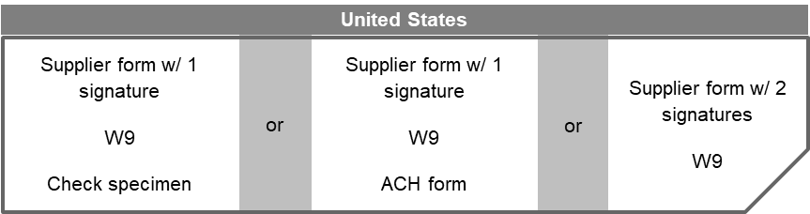
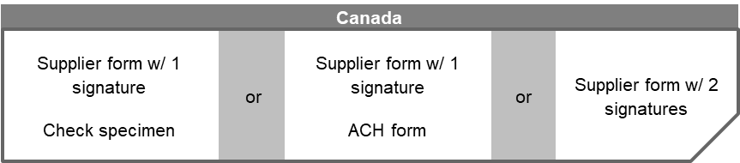
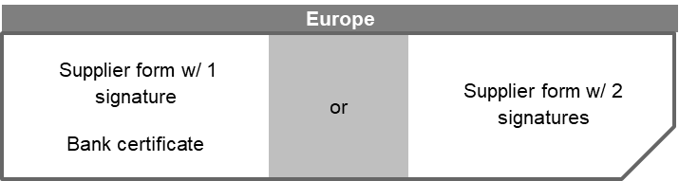

If you would like to include any additional information, please leave your comment here:
Comment: Click or tap here to enter text.

Thank You.
klöckner pentaplast

01/
Company name: Click or tap here to enter text.
Registered address: Click or tap here to enter text.
Plant address: Click or tap here to enter text.
Phone number :Click or tap here to enter text.
Fax number: Click or tap here to enter text.

02/
Ordering e-mail address: Click or tap here to enter text.
Sales e-mail address: Click or tap here to enter text.
Finance e-mail address: Click or tap here to enter text.

03/

Tax number: Click or tap here to enter text.
Currency: Click or tap here to enter text.
Incoterms: Click or tap here to enter text.
Bank details: Click or tap here to enter text.

The undersigned hereby stated that the information provided is valid and correct on the date of submission.

Name: Click or tap here to enter text.
Position: Click or tap here to enter text.
Date: Click or tap here to enter text.
Signature_________________________
Name: Click or tap here to enter text.
Position: Click or tap here to enter text.
Date : Click or tap here to enter text.
Signature__________________

